**FOR IMMEDIATE RELEASE**

**MEDIA CONTACTS :**

**Adaora Onyebeke**

[adaora@philharmonicsociety.org](mailto:adaora@philharmonicsociety.org)

**Marie-Songco Torres**

[marie@philharmonicsociety.org](mailto:marie@philharmonicsociety.org)

**LONDON SYMPHONY ORCHESTRA AND WORLD-RENOWNED PIANIST YUNCHAN LIM TO PERFORM IN ORANGE COUNTY THIS WINTER**

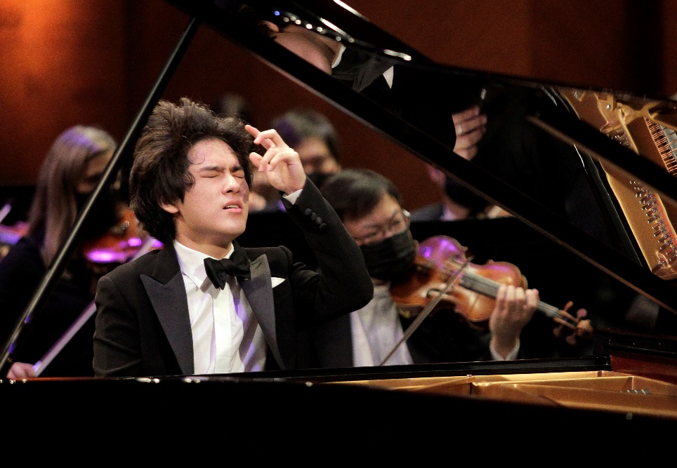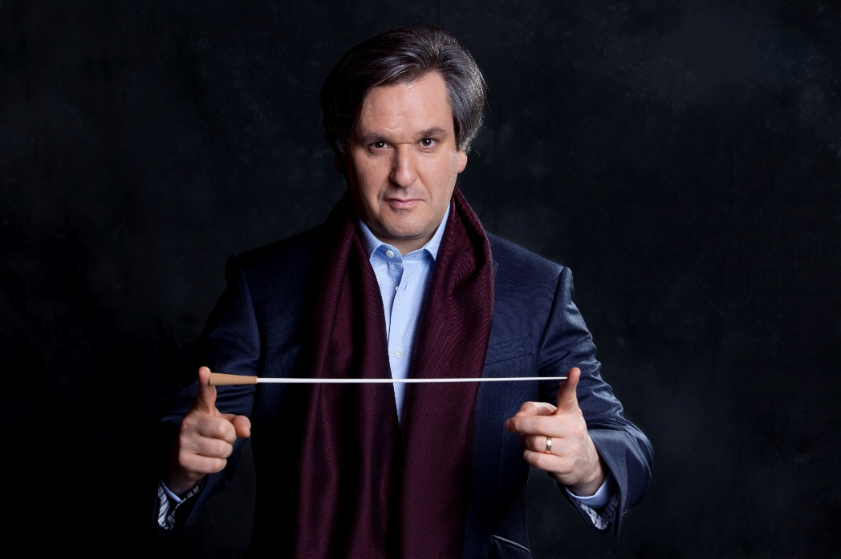

Photo: Musacchio & Ianniello

Photo: Mark Allan

Photo: Richard Rodriguez

**(IRVINE, CA, NOVEMBER 26, 2024)**— The Philharmonic Society of Orange County continues its 2024-25 season with an upcoming performance by the London Symphony Orchestra (LSO), featuring world-renowned pianist Yunchan Lim and conducted by Sir Antonio Pappano in his Orange County debut on Thursday, February 20, 2025, at 8 p.m. at the Renée and Henry Segerstrom Concert Hall. A pre-concert lecture with KUSC’s Brian Lauritzen will begin at 7pm.

Pappano leads the orchestra in a program of Rachmaninoff’s Piano Concerto No. 2, featuring acclaimed pianist Yunchan Lim, and Mahler’s monumental Symphony No. 1, “Titan”.

This concert is part of the Donna L. Kendall Classical Series, Henry T. and Elizabeth Segerstrom Foundation Select Series, and Steven M. Sorenson Signature Artist Series, with featured artist sponsors Michelle and David Horowitz.

The **London Symphony Orchestra** was established in 1904 as one of the first orchestras shaped by its musicians. Since then, generations of remarkable talents have built the LSO’s reputation for quality, daring, ambition and a commitment to sharing the joy of music with everyone. Today, the LSO is ranked among the world’s top orchestras, reaching tens of thousands of people in London, on stages around the world, and millions through streaming, downloads, radio and television.

As Resident Orchestra at the Barbican since the Centre opened in 1982, the LSO performs some 70 concerts there every year with its family of artists: Chief Conductor Sir Antonio Pappano, Conductor Emeritus Sir Simon Rattle, Principal Guest Conductors Gianandrea Noseda and François-Xavier Roth, Conductor Laureate Michael Tilson Thomas, and Associate Artists Barbara Hannigan and André J Thomas. The LSO has major artistic residencies in Paris, Tokyo and at the Aix-en-Provence Festival, and a growing presence across Australia.

The LSO’s record label LSO Live celebrates its 25th anniversary in 2024/25, and is a leader among orchestra-owned labels, bringing to life the excitement of a live performance. The catalogue of over 200 acclaimed recordings reflects the artistic diversity of the Orchestra–from popular new releases, such as Janáček’s *Katya Kabanova* with Sir Simon Rattle, to favorites like Vaughan Williams’ Symphonies with Sir Antonio Pappano and Verdi’s *Requiem* with Gianandrea Noseda.

Renowned for his charismatic leadership and inspirational performances across symphonic and operatic repertoire, GRAMMY® winner, **Sir Antonio Pappano** is among today’s most sought-after conductors. Chief Conductor Designate of the London Symphony Orchestra (beginning in the 2024/25 season), he has served as Music Director of the Royal Opera House, Covent Garden, since 2002. Pappano is also Music Director Emeritus of the Orchestra dell’Accademia Nazionale di Santa Cecilia in Rome, following a tenure as its Music Director from 2005 to 2023.

A nurtured pianist and repetiteur, Pappano’s career began with formative roles at leading opera houses, including the Lyric Opera of Chicago and several seasons at the Bayreuth Festival as musical assistant to Daniel Barenboim. He has held significant posts, such as Music Director of Oslo’s Den Norske Opera (1990), the Théâtre Royal de la Monnaie in Brussels (1992–2002), and Principal Guest Conductor of the Israel Philharmonic (1997–1999).

Pappano is in demand worldwide, conducting at the Metropolitan Opera, Vienna and Berlin State Operas, Salzburg and Bayreuth Festivals, and Teatro alla Scala. He has appeared with elite orchestras, including the Berlin, Vienna, and New York Philharmonics; the Royal Concertgebouw Orchestra; the Bavarian Radio, Chicago, and Boston Symphonies; the Philadelphia and Cleveland Orchestras; and the Gewandhausorchester Leipzig. Pappano also enjoys a strong relationship with the Chamber Orchestra of Europe.

Highlights of the 2024/25 season and beyond include return visits to Boston Symphony, the Chamber Orchestra of Europe, the Royal Concertgebouw Orchestra, the Gewandhausorchester Leipzig and a new production of Die Walkure at the Royal Opera House. In his ﬁrst season as Chief Conductor of the London Symphony, Pappano takes the orchestra on a wide-ranging touring to the USA, including Carnegie Hall, Japan, Korea, China and across major European capitals and festivals.

Pappano has been an exclusive recording artist for Warner Classics (formerly EMI Classics) since 1995, and his discography features numerous complete operas, including Don Carlo, La Rondine, Guillaume Tell, Il Trittico, Werther, Il Trovatore, Tristan und Isolde, and Aida. 2022 saw the release on Sony Classical of Verdi’s Otello, and a disc of Verdi duets with Jonas Kaufmann and Ludovic Tezier, and Vaughan William’s 4th and 6th symphonies for LSO Live, and in 2023 Warner released the ﬁrst studio recording of Puccini's Turandot with the complete conclusion by Alfano, recorded in Rome with Accademia Nazionale di Santa Cecili.

Since becoming the youngest ever gold medalist at the Van Cliburn International Piano Competition at age 18 in 2022, South Korean pianist **Yunchan Lim’s** rise to international stardom has been meteoric. Conductor Marin Alsop expressed: *“*Yunchan is that rare artist who brings profound musicality and prodigious technique organically together*.”*

In the years following his Cliburn win, Yunchan made successful orchestral debuts with the New York, Los Angeles, Munich, and Seoul Philharmonic orchestras, as well as Chicago, Lucerne, BBC, Boston, and Tokyo Symphony orchestras, among others. Recital appearances include performances at Carnegie Hall, Verbier Festival, the Wigmore Hall, Het Concertgebouw, and Suntory Hall, among other major stages.

Lim’s 2024/25 season highlights include orchestral debuts with Washington National Symphony, London Symphony, Royal Philharmonic, Vienna Radio Symphony, Berlin Radio Symphony, and WDR Symphony Orchestras, as well as returning to New York Philharmonic, Lucerne Symphony Orchestra, and Orchestra de Paris. This season will also see his recital debut at the Kennedy Center, and a return to Carnegie Hall.

As an exclusive Decca Classics recording artist, Yunchan Lim’s acclaimed debut studio album, *Chopin Études Op.10 & 25* has gone double platinum in South Korea and topped the classical charts around the world.

Renée and Henry Segerstrom Concert Hall is located at 615 Town Center Drive, Costa Mesa, CA 92626. A limited number of tickets remain available for this concert. For more information, contact the Philharmonic Society Box Office at (949) 553-2422, ext. 1 or at boxoffice@philharmonicsociety.org

**ABOUT THE PHILHARMONIC SOCIETY:**

Founded in 1954 as Orange County’s first music organization, the Philharmonic Society of Orange County presents national and international performances of the highest quality and provides dynamic and innovative music education programs for individuals of all ages to enhance the lives of Orange County audiences through music.

Since its inception, the Philharmonic Society has evolved and grown with the county’s changing landscape, presenting artists and orchestras who set the standard for artistic achievement from Itzhak Perlman, Gustavo Dudamel, Yo-Yo Ma, and Renée Fleming to the Berlin Philharmonic, Vienna Philharmonic, Chicago Symphony Orchestra, and many others. In addition, the Philharmonic Society celebrates multi-disciplinary performances under its Eclectic Orange brand and embraces music from a wide range of countries with its World Music performances. Its celebrated concerts introduce children to classical music with creative and inspiring performances, instilling music appreciation for future generations.

The Philharmonic Society’s nationally recognized Youth Music Education Programs, offered free of charge, engage more than 100,000 students annually through curriculum-based music education programs that aim to inspire, expand imaginations, and encourage learning at all levels. These programs are made possible by the Committees of the Philharmonic Society comprised of 500 volunteer members who provide more than 90,000 hours of in-kind service each year. As a key youth program, the exceptional Orange County Youth Symphony and String Ensemble provide top-tier training to the area’s most talented young musicians through multi-level ensemble instruction, leadership training, touring opportunities, challenging professional repertoire, and performances in world-class venues. The Philharmonic Society also promotes life-long learning by connecting with colleges and universities to conduct masterclasses and workshops and providing pre-concert lectures to introduce audiences to program selections.

**MEDIA CONTACTS :**

**MEDIA CONTACTS :**

**Adaora Onyebeke**

[adaora@philharmonicsociety.org](mailto:adaora@philharmonicsociety.org)

**Marie-Songco Torres**

[marie@philharmonicsociety.org](mailto:marie@philharmonicsociety.org)

**WHAT:** London Symphony Orchestra

Sir Antonio Pappano, conductor

Yunchan Lim, piano

**WHEN:** Thursday, February 20, 2025, 8pm

**PROGRAM:** **RACHMANINOFF:** Piano Concerto No. 2 in C minor, Op. 18

**MAHLER:** SymphonyNo. 1 in D major, "Titan"

Pre-concert lecture by KUSC’s Brian Lauritzen, 7pm

**WHERE:** Renée & Henry Segerstrom Concert Hall, Segerstrom Center for the Arts

615 Town Center Drive, Costa Mesa, CA 92626

**TICKETS:** A limited number of tickets remain available for this concert. For more information, contact the Philharmonic Society Box Office at

(949) 553-2422, ext. 1 or at boxoffice@philharmonicsociety.org